##### **HealthCare Service Provider System**

# A PROJECT REPORT

**for**

**Mini Project-II (ID201B)**

**Session (2024-25)**

**Submitted by Monika Tyagi**

**(202410116100123)**

**Mukul Dhiman**

**(202410116100126)**

**Minakshi Tomar**

**(202410116100119)**

**Submitted in partial fulfilment of the**

**Requirements for the Degree of**

MASTER OF COMPUTER APPLICATION

**Under the Supervision of**

**Ms. Shruti Aggarwal**

**Assistant Professor**



**Submitted to**

**Department Of Computer Applications**

**KIET Group of Institutions, Ghaziabad**

**Uttar Pradesh-201206**

**(March - 2025)**

# CERTIFICATE

Certified that **Monika Tyagi 202410116100123, Mukul Dhiman 202410116100126, Minakshi Tomar 202410116100119** has/ have carried out the project work having “**Healthcare Services Provider System**” (**Mini Project-II, ID102B**) for **Master of Computer Application** from Dr. A.P.J. Abdul Kalam Technical University (AKTU**)** (formerly UPTU), Lucknow under my supervision. The project report embodies original work, and studies are carried out by the student himself/herself and the contents of the project report do not form the basis for the award of any other degree to the candidate or to anybody else from this or any other University/Institution.

**Miss. Shruti Aggarwal Dr. Akash Rajak**

**(Assistant Professor) (Dean)**

**Department of Computer Applications Department of Computer Applications**

**KIET Group of Institutions, Ghaziabad KIET Group of Institutions, Ghaziabad**

# DECLARATION

##### We hereby declare that the work presented in this report entitled **“ HEALTHCARE SERVICE PROVIDER SYSTEM",** was carried out by us. We have not submitted the matter embodied in this report for the award of any other degree or diploma of any other University or Institute. We have given due credit to the original authors/sources for all the words, ideas, diagrams, graphics, computer programs, experiments, results, that are not my original contribution. We have used quotation marks to identify verbatim sentences and given credit to the original authors/sources. We affirm that no portion of my work is plagiarized, and the experiments and results reported in the report are not manipulated. In the event of a complaint of plagiarism and the manipulation of the experiments and results, We shall be fully responsible and answerable.

**Name : Monika Tyagi** (202410116100123)

**Mukul Dhiman** (202410116100126)

**Minakshi Tomar** (20241011610119)

**Branch : MCA**

## 

## HEALTHCARE SERVICE PROVIDER SYSTEM

**MONIKA TYAGI**

**MUKUL DHIMAN**

**MINAKSHI TOMAR**

## ABSTRACT

The **Healthcare Service Provider System** is a web-based application designed to enhance the efficiency, accessibility, and quality of healthcare services. With the growing demand for digital solutions in the medical field, this system serves as a bridge between patients, healthcare providers, and administrators by offering a centralized platform for managing medical records, scheduling appointments, and providing virtual consultations. It aims to minimize delays in medical services, improve patient-doctor interaction, and streamline administrative processes within healthcare facilities.

The system enables **patients** to register, book appointments, access their medical history, receive telemedicine services, and obtain prescriptions online, thereby reducing the need for physical visits and long waiting times. **Healthcare professionals** can efficiently manage patient records, prescribe medications, monitor treatment progress, and communicate with patients through an integrated dashboard, ensuring accurate and timely healthcare delivery. **Administrators** can oversee hospital operations, manage staff, track patient data, and ensure compliance with medical regulations, thereby enhancing hospital efficiency and resource management.

Developed using **HTML, CSS, JavaScript, and SQL**, the system ensures a seamless, user- friendly experience while maintaining high standards of data security, confidentiality, and accessibility. By digitizing and automating essential healthcare processes, the **Healthcare Services Provider System** aims to improve patient care, optimize resource utilization, reduce operational costs, and enhance the overall efficiency of healthcare facilities. This system contributes to the modernization of healthcare services by integrating advanced digital solutions that facilitate smooth communication, improved record management, and an enhanced patient experience.

## ACKNOWLEDGEMENT

Success in life is never attained single-handedly. I am deeply grateful to my project supervisor, **Miss. Shruti Aggarwal**, for his invaluable guidance, unwavering support, and encouragement throughout my project work. His enlightening ideas, constructive comments, and thoughtful suggestions have greatly contributed to the completion of this project.

I would also like to extend my heartfelt thanks to **Dr. Akash Rajak**, Professor and Dean, Department of Computer Applications, for his insightful feedback and administrative support on various occasions, which proved to be immensely helpful during critical stages of the project.

I am fortunate to have many understanding friends who have supported me in numerous ways during challenging moments. Their assistance and companionship have been a constant source of motivation.

Finally, my sincere gratitude goes to my family members and all those who have directly or indirectly provided me with moral support, encouragement, and assistance. Their unwavering belief in me and their continuous efforts to keep my life filled with happiness and joy made the completion of this project possible.

**Monika Tyagi**

**Mukul Dhiman**

**Minakshi Tomar**

# TABLE OF CONTENTS

Certificate 02

Declaration. 03

Abstract. 04

Acknowledgements. 05

List of Figures 08

1. INTRODUCTION ………..…………………………………………………………....10
   1. General 09
   2. Overview of the Healthcare Service Provider …………………………………….09
   3. Purpose of the System ...09
   4. Key Features and Functionalities …………………………………………………10
   5. Integration with External Systems 10
   6. Benefits of the Healthcare Services Provider System 10
      1. For Hospitals & Clinics 10
      2. For Patients 10
2. LITERATURE REVIEW …………………………………………………………....13
   1. Technologies Used in HSPS……………………………………………………….11
   2. Key Functionalities of HSPS……………………………………………………....11
   3. Challenges in Developing HSPS…………………………………………………..12

2.3.1 Data Security & Privacy……………………………………………………..12

* + 1. Real-Time Data Management……………………………………………….12
    2. Scalability & System Performance………………………………………….12

2.3.4 User Authentication & Role-Based Access………………………………….12

2.3.5 Integration with External Healthcare Systems………………………………12

2.3.6 Regulatory Compliance……………………………………………………..12

* 1. Future Directions and Enhancements……………………………………………..13

1. PROJECT OBJECTIVE 15
   1. Implementing Secure Patient and Doctor Registration…………………………..14
   2. Enabling Real-Time Appointment Booking and Scheduling…………………….14
   3. Digital Medical Record Management…………………………………………….14
   4. Providing Telemedicine and Virtual Consultation Services …………………….14
   5. Hospital Administration and Resource Management…………………………….15
   6. Ensuring Data Security and Compliance…………………………………………15
2. HARDWARE AND SOFTWARE REQUIREMENTS……………………………..17
   1. Hardware Requirement 16
   2. Software Requirement 17
3. PROJECT FLOW ………..…………………………………………………………....23
   1. Development Methodology 18
   2. **System Design and Architecture**  .18
   3. **Development Process (Agile Sprints)**  **19**
   4. **Testing Strategy 19**
   5. **Deployment 19**
   6. **Maintenance and Updates 20**
   7. Future Enhancements 20
   8. Data Flow And UseCase Diagram 23
4. PROJECT OUTCOME………………………………………………………………..24
   1. User-Friendly Interface…………………………………………………………….24
   2. Efficient Administrative Panel …………………………………………………….24
   3. Secure and Scalable Database Management ………………………………………24
   4. Responsive and Accessible Design ………………………………………………..24
   5. Optimized System Performance……………………………………………………24
5. **REFERENCES………………………………………………………………………..31**

# LIST OF FIGURES

* 1. Use Case Diagram 21
  2. ER Diagram 22
  3. Data Flow Diagram Level 0 22
  4. Data Flow Diagram Level 1 23
  5. Admin Login Page 25
  6. Customer Sign Up Page 25
  7. Customer Sign In Page 26
  8. Home Page 27
  9. Book Appointment 28
  10. Book Appointment Successfully 28
  11. Admin Login Database 29
  12. Customer Sign up Database 29
  13. Book Appointment Database 30

## INTRODUCTION

### General

The **Healthcare Service Provider** is a web-based platform designed to modernize and streamline healthcare management by integrating digital solutions for patients, healthcare providers, and administrators. Traditional healthcare systems often face challenges such as inefficient appointment scheduling, delayed medical record access, long patient wait times, and increased administrative workload. These inefficiencies can lead to poor patient experiences, overburdened medical staff, and difficulties in maintaining organized medical records. This system addresses these issues by providing a centralized, automated solution that enhances patient care, operational efficiency, and overall healthcare service delivery.

Healthcare is a fundamental aspect of human well-being, and efficient management of healthcare services is essential for delivering quality patient care. Traditional healthcare management systems often face challenges such as **manual record-keeping, delayed appointment scheduling, lack of accessibility, and inefficient hospital administration**. To address these issues, a **Healthcare Service Provider** is designed as a **web-based platform** that integrates various healthcare services to enhance accessibility, streamline medical processes, and improve overall efficiency.

**1.2 Overview of the Healthcare Service Provider**

The **Healthcare Services Provider** is a **centralized digital solution** that connects **patients, doctors, and hospital administrators** on a single platform. It simplifies critical operations such as **patient registration, appointment booking, medical record management, telemedicine consultations, and hospital administration**. By leveraging technology, this system improves efficiency, enhances patient experiences, and ensures secure data management.

**1.3 Purpose of the System**

The primary goal of the **Healthcare Service Provider** is to provide a **user-friendly and efficient digital platform** that benefits both **patients and healthcare providers**.

* + - **For Patients:** It enables users to **book appointments, access their medical history, receive online consultations, and get real-time health updates**.
    - **For Healthcare Professionals:** It helps doctors efficiently **manage patient records, prescribe medications, monitor treatment progress, and schedule appointments**.
    - **For Administrators:** It facilitates **staff management, hospital resource allocation, and compliance monitoring**, ensuring smooth hospital operations.

**1.4 Key Features and Functionalities**

The Healthcare Service Provider includes essential features such as:

* + - **Online Appointment Booking:** Patients can schedule appointments based on doctor availability.
    - **Electronic Medical Records (EMR):** Securely stores and manages patient health records for easy access.
    - **Telemedicine Integration:** Enables remote consultations via **video calls and chat- based support**.
    - **Prescription Management:** Doctors can issue **digital prescriptions**, reducing paperwork.
    - **Real-Time Notifications:** Provides updates on **appointments, lab results, and medication reminders**.
    - **Hospital Administration Dashboard:** Helps administrators manage **staff, resources, and compliance reports**.

**1.5 Integration with External Systems**

To ensure smooth operations, the **Healthcare Services Provider System** is integrated with **external healthcare databases, payment gateways, lab management systems, and pharmacy networks**. This enables **seamless data exchange, automated billing, and better patient care coordination**.

* 1. **Benefits of the Healthcare Services Provider System**

1.6.1For Hospitals & Clinics:

* + Automates **appointment scheduling, patient record-keeping, and staff management**.
  + Enhances **efficiency, accuracy, and compliance** with healthcare regulations.
  + Provides **data analytics and reporting** to track hospital performance and patient trends.

1.6.2For Patients:

* + Offers **easy access** to medical records and doctor consultations.
  + Reduces waiting times with **efficient appointment booking**.
  + Provides **secure, confidential healthcare services** through a digital platform.

## LITEEATURE REVIEW

A **Healthcare Service Provider** is an integrated digital platform that enables **patients, doctors, and hospital administrators** to manage essential healthcare operations efficiently. Patients can **book appointments, access medical records, and receive virtual consultations**, while healthcare providers can **track patient history, prescribe medications, and monitor treatment progress**. Administrators can manage **hospital resources, staff, and compliance requirements**, ensuring smooth operational workflows.

* 1. **Technologies Used in HSPS**

Modern **Healthcare Services Provider Systems** leverage various technologies to ensure secure, scalable, and efficient healthcare management.

* + - **Frontend Technologies:** HTML, CSS, and JavaScript are commonly used to develop an intuitive and responsive user interface for patients, doctors, and hospital staff.
    - **Backend Technologies:** Java, Python, or Node.js are used to manage server-side processes, such as handling user requests, retrieving patient data, and managing authentication.
    - **Database Management:** SQL or NoSQL databases (MySQL, PostgreSQL, MongoDB) store **patient records, appointment details, prescriptions, and medical reports** while ensuring data security and integrity.
  1. **Key Functionalities of HSPS**

A **Healthcare Services Provider System** typically includes the following essential features:

* **Online Appointment Scheduling:** Patients can book, reschedule, or cancel appointments based on doctor availability.
* **Electronic Medical Records (EMR):** Secure storage and retrieval of patient history, diagnostic reports, and prescriptions.
* **Telemedicine & Virtual Consultations:** Enables remote healthcare services via **video calls and chat-based doctor interactions**.
* **Prescription & Medication Management:** Doctors can generate and share **e- prescriptions**, reducing paperwork and errors.
* **Hospital Administration & Staff Management:** Allows administrators to **monitor hospital operations, manage doctor schedules, and oversee patient admissions**.
* **Billing & Payment Integration:** Facilitates **secure online payments, medical billing, and insurance claim processing**.
* **Real-Time Alerts & Notifications:** Keeps patients informed about **appointments, prescription refills, and lab results**.
  1. **Challenges in Developing HSPS**

Developing a **Healthcare Services Provider System** involves multiple challenges, particularly in ensuring security, scalability, and efficiency.

* + 1. **Data Security & Privacy:**
* Protecting **patient data from unauthorized access and cyber threats**.
* Ensuring compliance with **healthcare regulations** such as **HIPAA and GDPR**.
  + 1. **Real-Time Data Management:**
* Handling **simultaneous appointment bookings and medical record updates**.
* Preventing **duplicate or inconsistent patient records**.
  + 1. **Scalability & System Performance:**
* Managing **high volumes of patient records, doctor schedules, and hospital operations**.
* Ensuring **fast response times** for seamless user experience.
  + 1. **User Authentication & Role-Based Access:**
* Implementing **secure login systems for patients, doctors, and hospital staff**.
* Restricting access based on **user roles (e.g., doctors can update prescriptions, while patients can only view them)**.
  + 1. **Integration with External Healthcare Systems:**
* Connecting with **pharmacy databases, insurance companies, and diagnostic centers**.
* Ensuring **accurate billing, insurance claims, and medical report sharing**.
  + 1. **Regulatory Compliance:**
* Adhering to **data protection laws, medical ethics, and hospital regulations**.
* Handling **patient consent management and medical record retention policies**.
  1. **Future Directions and Enhancements**

Future advancements in **Healthcare Services Provider Systems** will incorporate **AI-driven healthcare, IoT-based remote monitoring, and blockchain for secure medical record management**.

1. **AI-Powered Predictive Analysis:**
   * Machine Learning algorithms can **analyze patient history and predict potential health risks**.
   * AI-based **chatbots for automated patient queries and appointment scheduling**.
2. **IoT-Based Health Monitoring:**
   * **Wearable health devices** can be integrated to track patient vitals in real time.
   * Enables **remote patient monitoring and emergency alerts**.
3. **Blockchain for Medical Records:**
   * Secure **decentralized storage of patient data**, preventing data breaches.
   * Enhances **data integrity and traceability of medical history**.
4. **Mobile App Integration:**
   * Mobile-friendly applications for **instant access to medical records, appointment scheduling, and telemedicine services**.

## PROJECT OBJECTIVE

The **Healthcare Service Provider** aims to enhance the efficiency, accessibility, and security of healthcare services by providing a web-based platform for seamless interaction between patients, healthcare professionals, and administrators. The project focuses on digitizing key healthcare processes, reducing manual workload, and improving patient care through an integrated, user- friendly system.

The primary objective of this project is to develop an efficient and user-friendly **Healthcare Services Provider System (HSPS)** that automates critical healthcare operations while improving patient care and administrative efficiency. The system will integrate key functionalities such as **patient registration, appointment booking, medical record management, and telemedicine services** to enhance accessibility and streamline healthcare workflows. The specific objectives of this project include:

* 1. **Implementing Secure Patient and Doctor Registration**

The system will provide a **secure and seamless registration/login process** for patients, doctors, and hospital administrators using **robust authentication mechanisms**. Features such as **encryption, password hashing, and session management** will ensure data security while preventing unauthorized access.

* 1. **Enabling Real-Time Appointment Booking and Scheduling**

Patients will be able to **search for available doctors**, select appointment slots, and book consultations in real-time. The system will optimize doctor availability by implementing **automated scheduling and rescheduling features**, reducing wait times and improving efficiency.

* 1. **Digital Medical Record Management**

The system will allow for **secure storage and retrieval of patient health records**, including **diagnostic reports, prescriptions, and treatment history**. Role-based access control (RBAC) will ensure that only authorized personnel can view or modify sensitive medical data.

* 1. **Providing Telemedicine and Virtual Consultation Services**

The platform will support **video consultations and chat-based interactions**, allowing patients to consult with doctors remotely. Doctors will be able to **prescribe medications and offer medical advice online**, enhancing accessibility for patients in remote areas.

* 1. **Hospital Administration and Resource Management**

The system will provide **hospital administrators with tools to manage staff, monitor operations, and generate reports**. Automated **inventory tracking and resource allocation** will improve hospital workflow efficiency.

* 1. **Ensuring Data Security and Compliance**

To protect sensitive patient information, the system will implement **data encryption, multi- factor authentication, and compliance with healthcare regulations** such as **HIPAA and GDPR**. These measures will ensure **confidentiality, integrity, and security of medical data**.

By achieving these objectives, the **Healthcare Services Provider System** will enhance healthcare accessibility, optimize medical processes, and improve patient-doctor interactions, ultimately contributing to a **more efficient and patient-centric healthcare ecosystem**.

## 4. HARDWARE AND SOFTWARE REQUIRMRNT

For the successful implementation of the **Healthcare Services Provider System**, the following **hardware and software** requirements are necessary.

## ****4.1 Hardware Requirements****

The hardware requirements for developing and running the Healthcare Services Provider System are as follows:

### ****Minimum Requirements****

* **Processor (CPU):** Intel Core i3 / AMD Ryzen 3 or equivalent (sufficient for basic development and testing).
* **RAM:** 4 GB (sufficient for lightweight development).
* **Storage:** 100 GB HDD or SSD (for storing code, database files, libraries, and logs).
* **Display:** Minimum resolution of 1366x768 pixels for basic UI design and development.
* **Internet Connection:** Broadband connection with at least 5 Mbps speed for accessing online libraries, deploying builds, and conducting virtual consultations in test scenarios.
* **Operating System:** Windows 10, or macOS (compatible with Java and MySQL tools).

### ****Recommended Requirements****

* **Processor:** Intel Core i5 / AMD Ryzen 5 or higher – ensures better multitasking performance, especially during server load testing or database operations.
* **RAM:** 8 GB or 16 GB – recommended for smooth running of IDEs, browsers, local servers, and testing tools concurrently.
* **Storage:** 256 GB SSD or higher – faster read/write access, improving development efficiency and application load time.
* **Display:** Full HD (1920x1080) or higher – improves clarity when working with split-screen code editors and browser windows.
* **Network:** Stable high-speed internet (10 Mbps or more) – ideal for testing telemedicine features (video call or chat), cloud deployments, and version control synchronization.

## ****4.2 Software Requirements****

To develop, deploy, and maintain the HSPS platform effectively, the following software tools and technologies are required:

### ****Operating Systems****

* **Supported OS:** Windows 10/11, Ubuntu Linux (20.04 or above), macOS Monterey or later.
* **Recommendation:** Ubuntu is preferred for development due to better compatibility with open-source tools and server environments.

### ****Development Tools and Technologies****

#### ****Frontend Technologies****

* **HTML5 & CSS3:** Used to build responsive and accessible layouts for healthcare portal pages.
* **JavaScript (ES6+):** Enhances interactivity – calendar pop-ups, form validation, appointment filters.

#### ****Backend Technologies****

* **Java (JDK 11 or above):** Required to write and compile Java Servlets for backend logic.
* **Apache Tomcat (v9 or v10):** Servlet container to deploy and test web application locally.
* **Servlet API:** Required to handle HTTP requests, session management, and business logic.

#### ****Database****

* **MySQL (v8.x):** Used for storing structured data – patient records, appointments, prescriptions, and doctor schedules.
* **MySQL Workbench / phpMyAdmin:** GUI tools for managing databases, writing queries, and debugging schema designs.

#### ****Build & Version Control Tools****

* **Apache Maven / Ant (optional):** For managing project dependencies and automating builds (optional with pure Servlet-based setups).
* **Git:** Version control system for tracking code changes.
* **GitHub / GitLab / Bitbucket:** For remote repository hosting, collaboration, and deployment workflows.

#### ****Development IDEs****

* **NetBeans IDE (Latest Version):** A robust and beginner-friendly IDE with built-in support for Java EE, Servlets, and web application development. Ideal for creating and deploying Java-based backend logic with integrated support for Tomcat and GlassFish servers.
* **Eclipse IDE (EE version):** Most compatible with Java Servlet projects and web app configuration.
* **Visual Studio Code (optional):** Can be used for frontend HTML, CSS, and JS development.

## 

## 5. PROJECT FLOW

## 

## ****5.1 Development Methodology****

The Healthcare Services Provider System follows the **Agile Development Methodology** to ensure flexibility, user feedback integration, and continuous delivery. The process includes the following phases:

### ****1. Requirement Gathering and Analysis****

* **Stakeholder Consultation:** Engage with healthcare providers, patients, and administrative staff to gather requirements.
* **Requirement Documentation:** Functional needs (appointments, patient records, telemedicine) and non-functional requirements (performance, security, scalability) are documented.
* **Market Study:** Analyze existing healthcare systems to identify key features, pain points, and innovation opportunities.

### ****5.2 System Design and Architecture****

#### ****Overview****

The system adopts a **three-tier architecture**:

#### ****a. Presentation Layer (Frontend)****

* **Technologies Used:** HTML5, CSS3, JavaScript
* **Responsibilities:**
  + Responsive user interface for patients and doctors.
  + Online forms for appointment booking, profile updates, and virtual consultations.
  + Integration of interactive features like calendars and search filters.

#### ****b. Business Logic Layer (Backend)****

* **Technologies Used:** Java Servlets
* **Responsibilities:**
  + Handle HTTP requests/responses, session management, and user authentication.
  + Process medical record retrieval, appointment logic, and prescription handling.
  + Communicate with the database and validate user input securely.

#### ****c. Data Layer (Database)****

* **Technologies Used:** MySQL
* **Responsibilities:**
  + Store and manage data related to users, appointments, prescriptions, doctors, and hospital staff.
  + Ensure data integrity, indexing for performance, and support for secure queries.

### ****5.3 Development Process (Agile Sprints)****

#### ****Sprint Planning****

* Each sprint targets a specific module (e.g., Patient Registration, Appointment Booking, Doctor Dashboard).

#### ****Daily Scrum Meetings****

* Track progress, address blockers, and adjust development priorities if needed.

#### ****Sprint Reviews****

* Demonstrate completed features to stakeholders and gather feedback.

#### ****Sprint Retrospectives****

* Reflect on the sprint and improve the next cycle’s efficiency and collaboration.

### ****5.4 Testing Strategy****

Testing is integrated into every sprint cycle.

* **Unit Testing:** Testing individual servlet methods and frontend scripts.
* **Functional Testing:** Validating appointment booking, medical record access, and login functionality.
* **Integration Testing:** Ensuring seamless communication between servlets and the MySQL database.
* **UI Testing:** Verifying responsiveness and interactivity of the frontend.
* **Security Testing:** Testing for unauthorized access, SQL injection, and session management vulnerabilities.

### ****5.5 Deployment****

* **Server Hosting:** Deploy the application on a local or cloud-based Tomcat server.
* **CI/CD:** Manual or script-based deployment for each major build.
* **Domain and SSL Configuration:** Secure the domain using HTTPS protocols and certificate configuration.

### ****5.6 Maintenance and Updates****

* **Monitoring:** Regularly monitor logs, performance, and user activity.
* **Feature Updates:** Roll out new features based on user feedback (e.g., AI health advice, live chat support).
* **Security Patching:** Keep servlet libraries and database connections secure and up-to-date.

### ****5.7 Future Enhancements****

* **AI-Based Health Predictions:** Recommend tests and treatments based on symptoms.
* **Chatbot Integration:** 24/7 virtual assistant for patients.
* **Real-Time Notifications:** Alerts for upcoming appointments, prescription refills, etc.
* **Mobile Optimization:** Further enhance accessibility for mobile users.

**5.8 USECASE DIAGRAM AND DFD DIAGRAM**

**USECASE DIAGRAM**

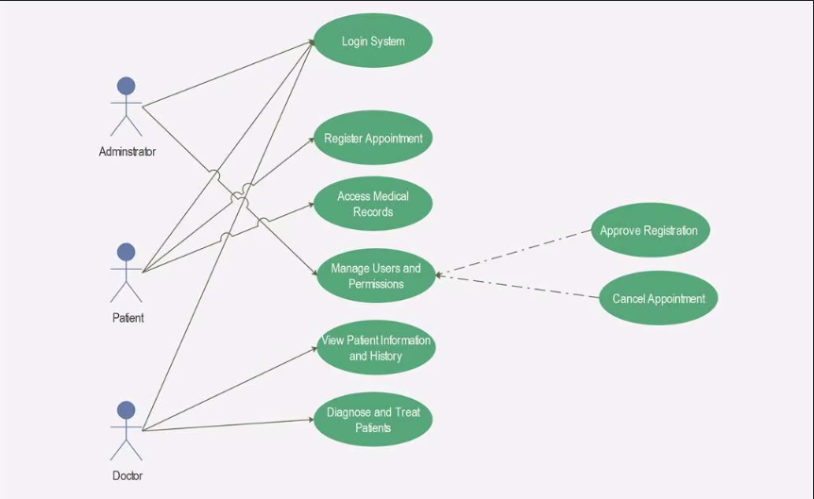

**Figure-1**

**ER DIAGRAM**

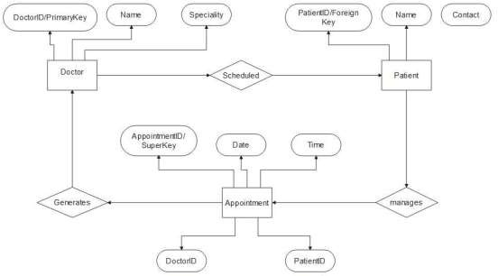

**Figure-2**

**DATA FLOW DIAGRAM**

**Level -0 DFD Diagram:-**

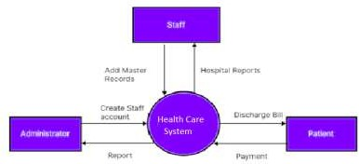

**Figure-3**

**Level -1 DFD Diagram:-**

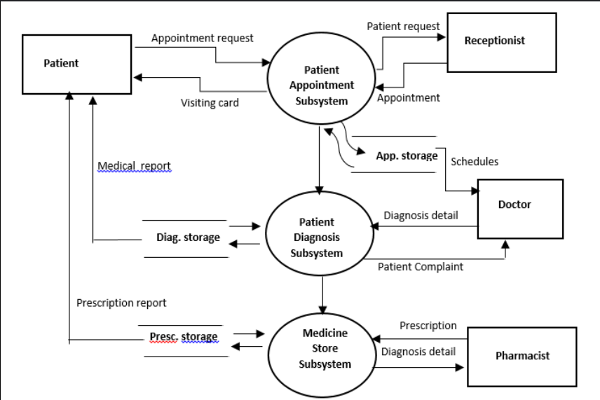

**Figure-4**

**6. PROJECT OUTCOMES**

The **Healthcare Service Provider (HSP)** aims to enhance the efficiency, accessibility, and security of healthcare services by digitizing and automating essential medical processes. The expected outcomes of this project include:

* 1. **User-Friendly Interface**

The system provides an **intuitive and easy-to-navigate interface**, allowing patients, doctors, and administrators to access necessary features **without confusion**. Patients can **book appointments, access medical records, and consult doctors** with ease, leading to improved **user satisfaction and engagement**.

* 1. **Efficient Administrative Panel**

Administrators can **effectively manage hospital operations, staff, and patient records**, reducing **manual errors and administrative workload**. Real-time insights into **appointments, hospital resources, and patient data** help improve decision-making and operational efficiency.

* 1. **Secure and Scalable Database Management**

The system ensures **fast, secure, and reliable data storage and retrieval**, minimizing downtime and ensuring that **critical patient and hospital information is always available when needed**. The **database is designed for scalability**, allowing future expansion without performance issues.

* 1. **Responsive and Accessible Design**

The platform is developed with **responsive web design**, ensuring seamless accessibility across **desktop, tablet, and mobile devices**. Patients and doctors can **access healthcare services anytime, anywhere**, improving the system’s reach and usability.

* 1. **Optimized System Performance**

The system is designed for **fast load times and smooth performance**, enhancing user experience and reducing delays. Secure authentication, **role-based access control**, and **data encryption mechanisms** contribute to a **safe and reliable healthcare platform**.

**Admin Login Page:**-

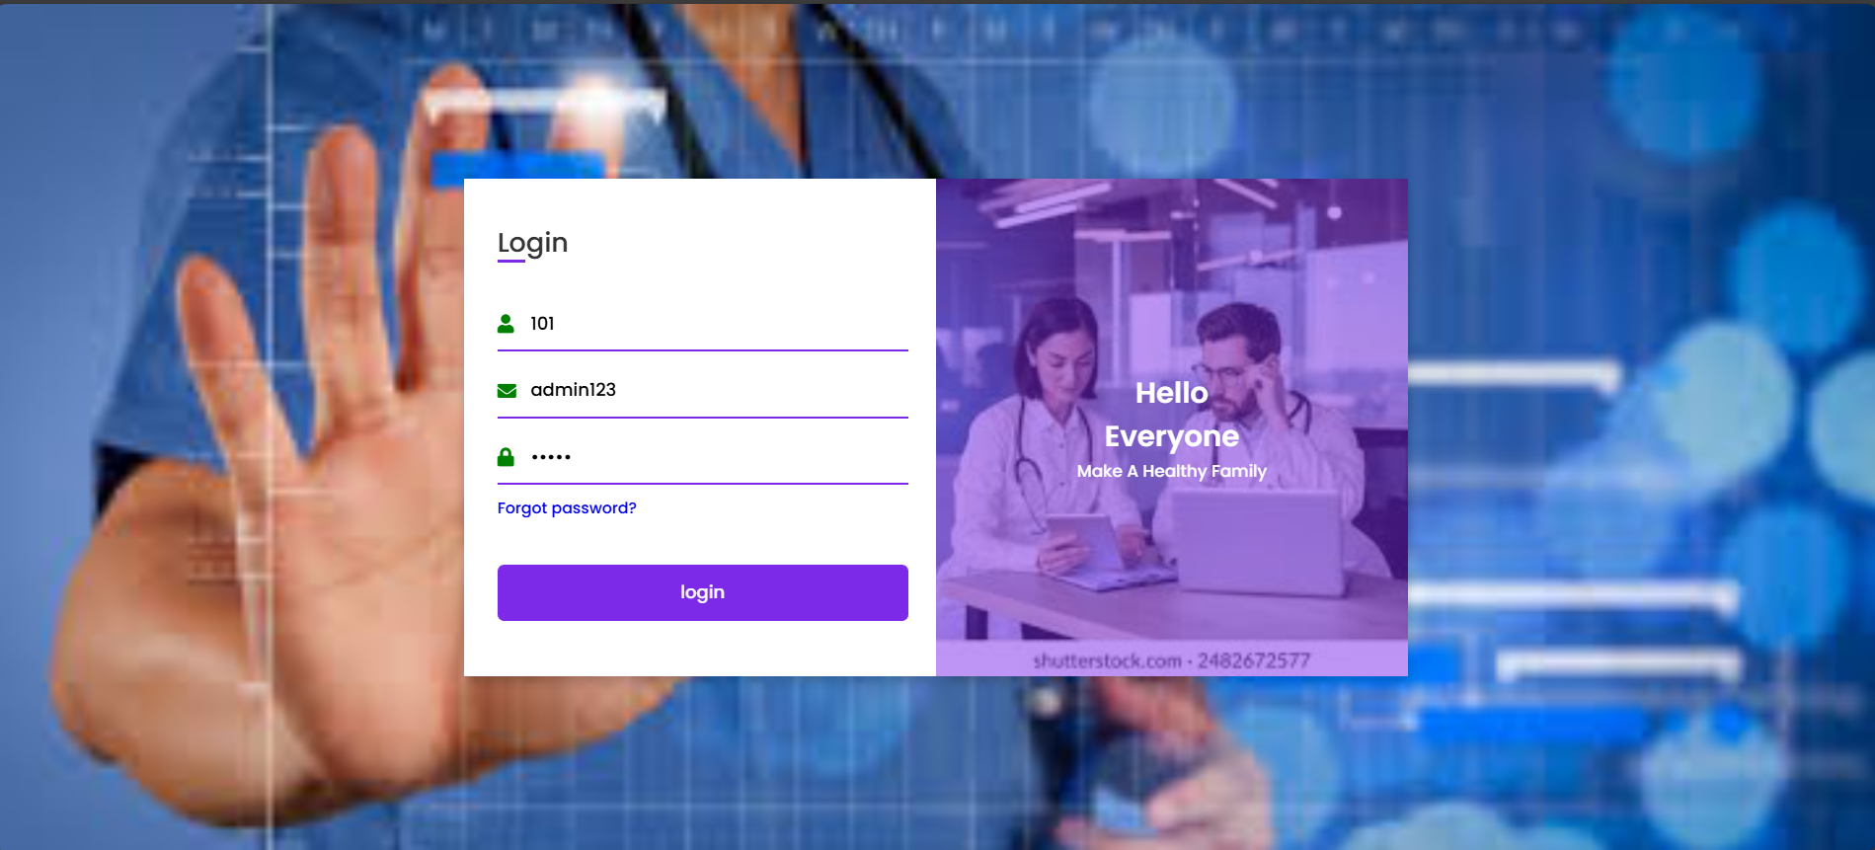

**Figure-5**

**Customer Sign up Page:**-

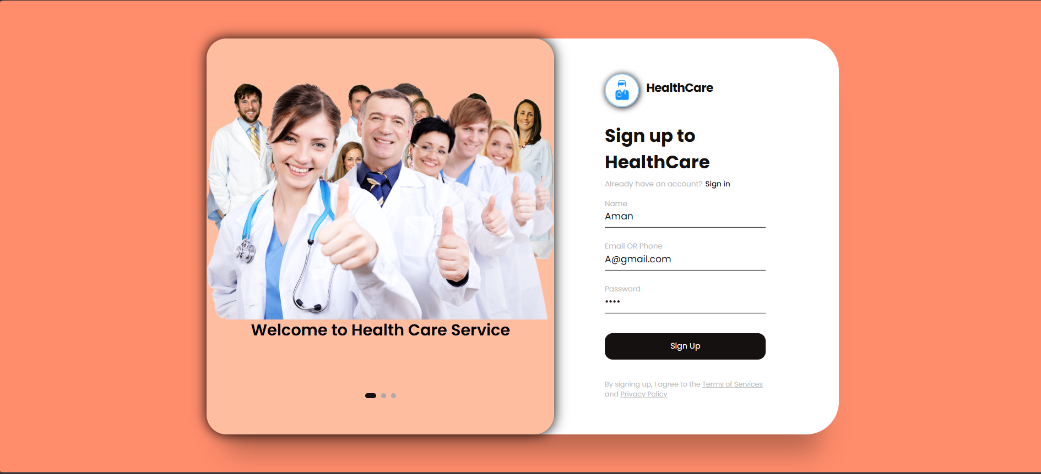

**Figure-6**

**Customer Sign in Page:**-

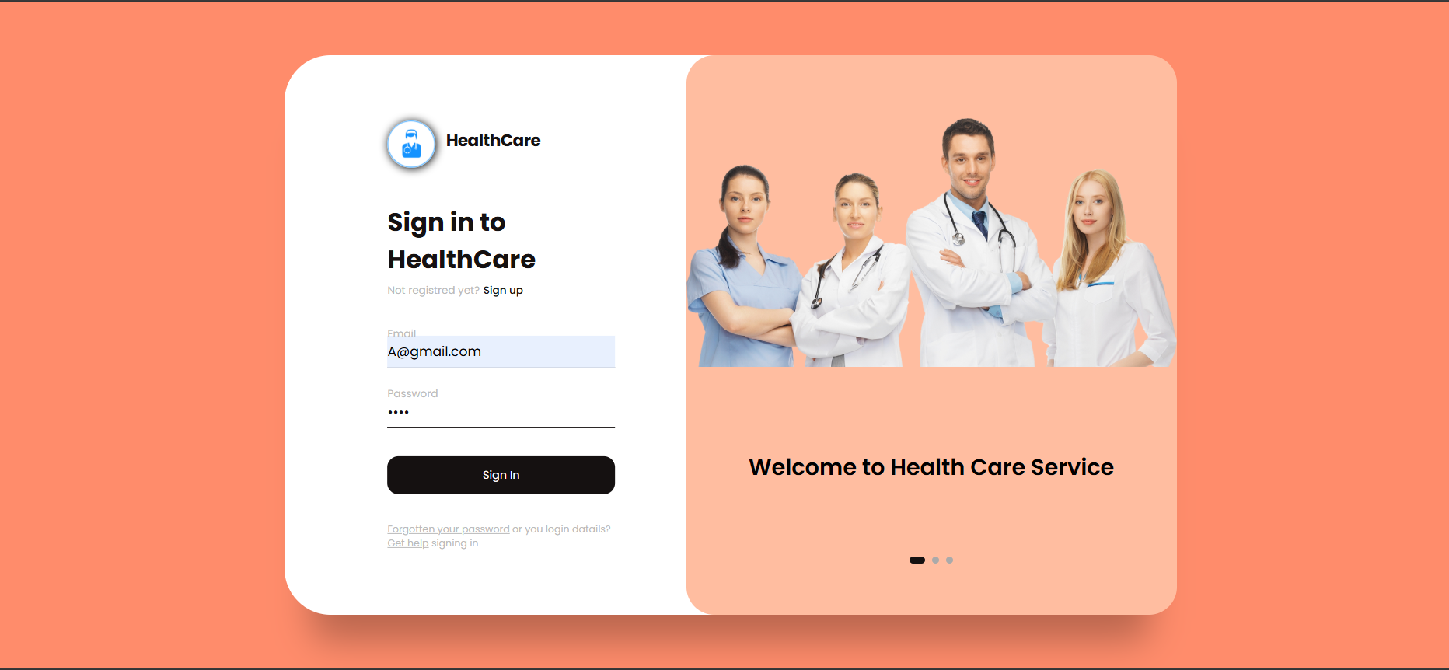

**Figure-7**

**Home Page:-**

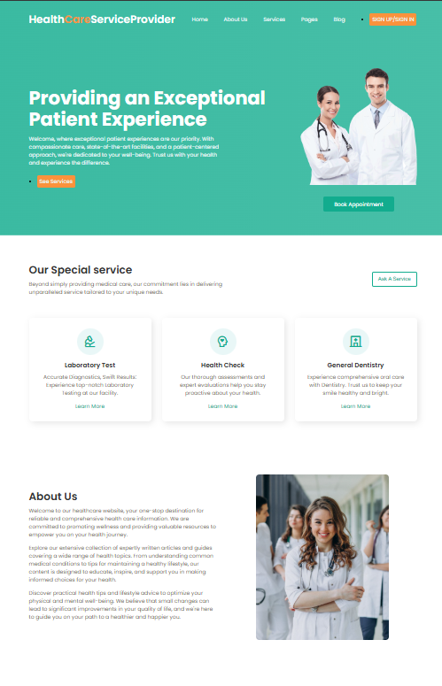

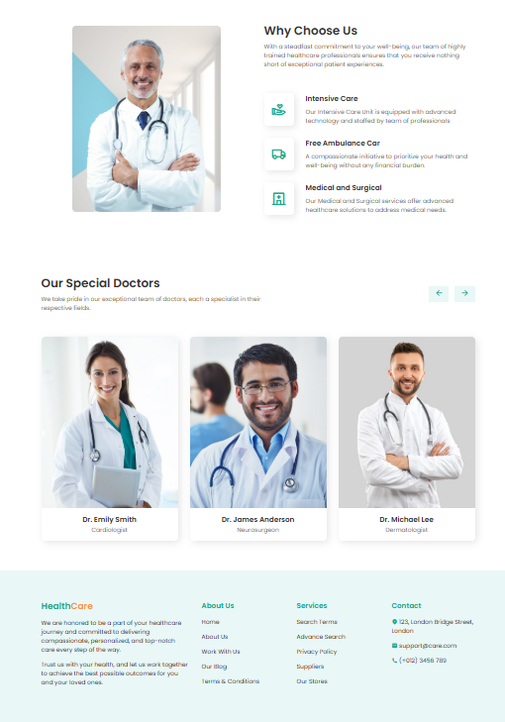

**Figure - 8**

**Book Appointment:-**

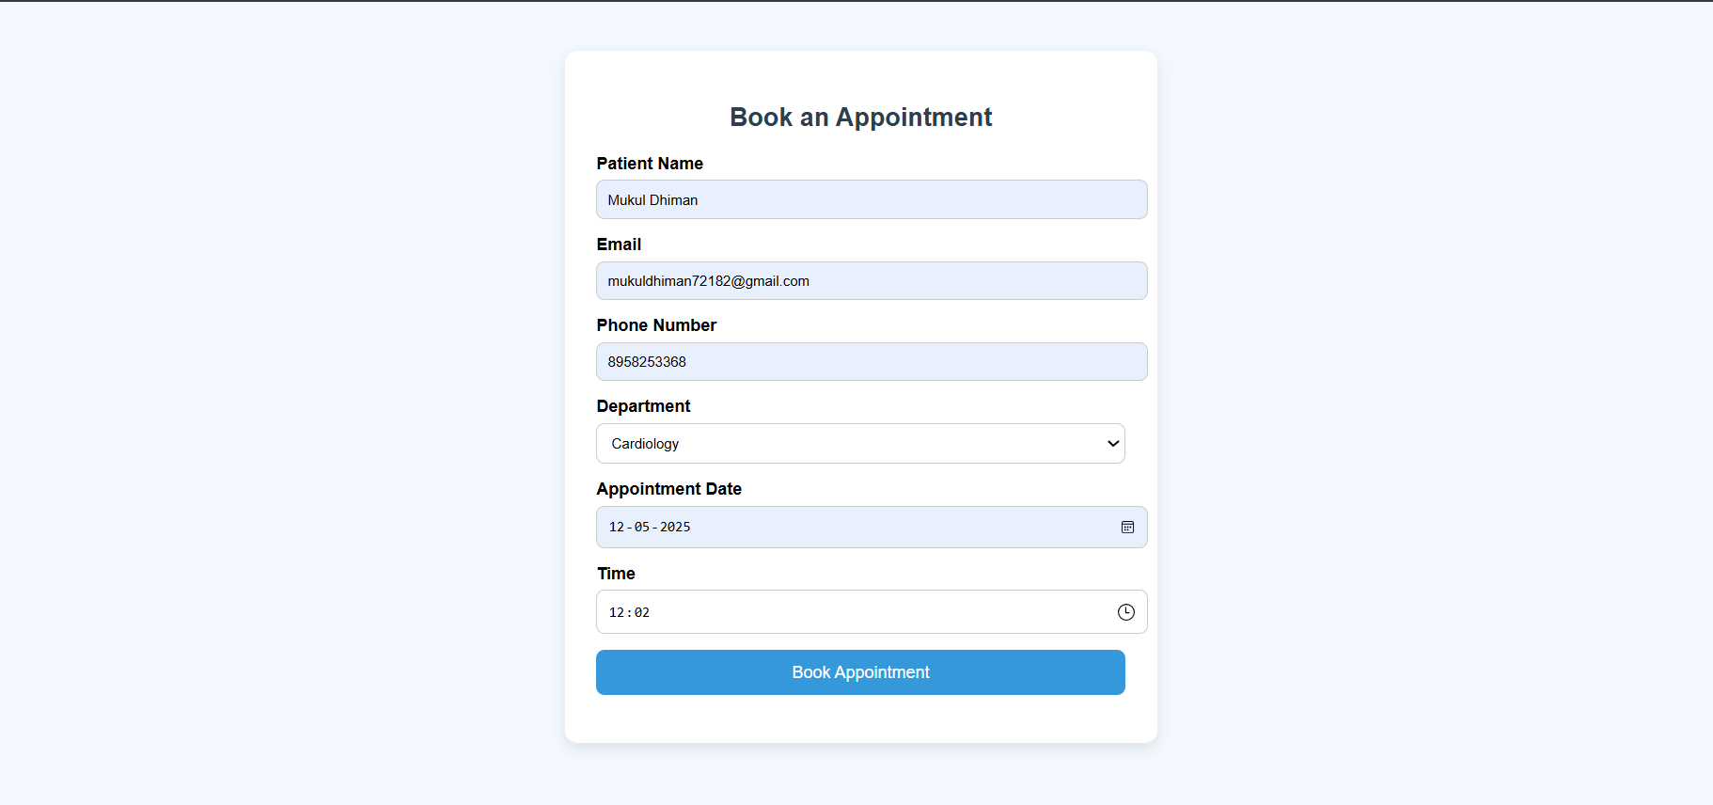

**Figure - 9**

**Book Appointment Successfully:-**

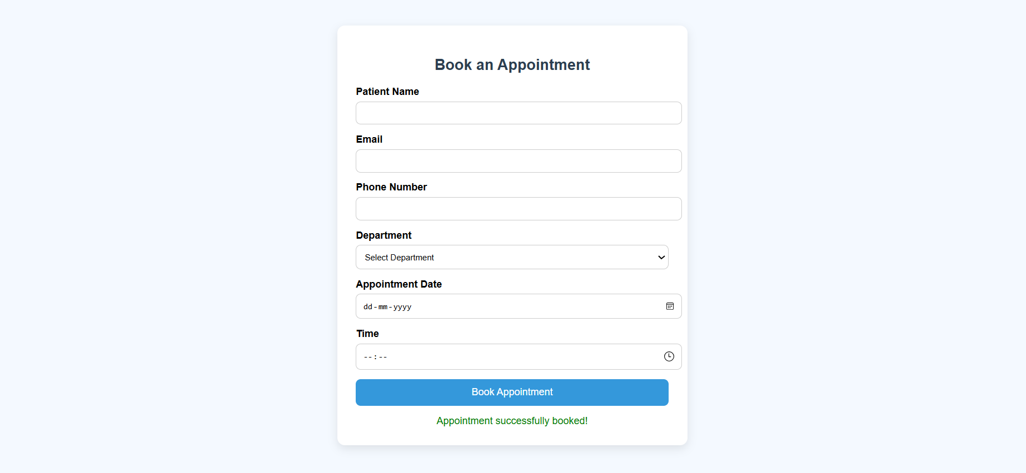

**Figure - 10**

**Admin Login Database:-**

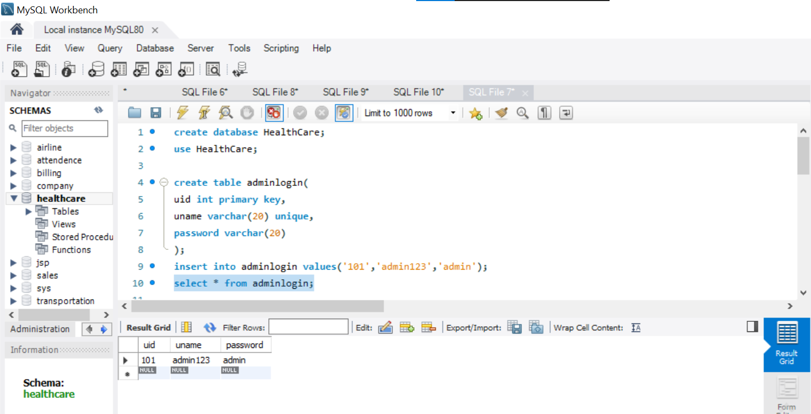

**Figure - 11**

**Customer Sign up Database:-**

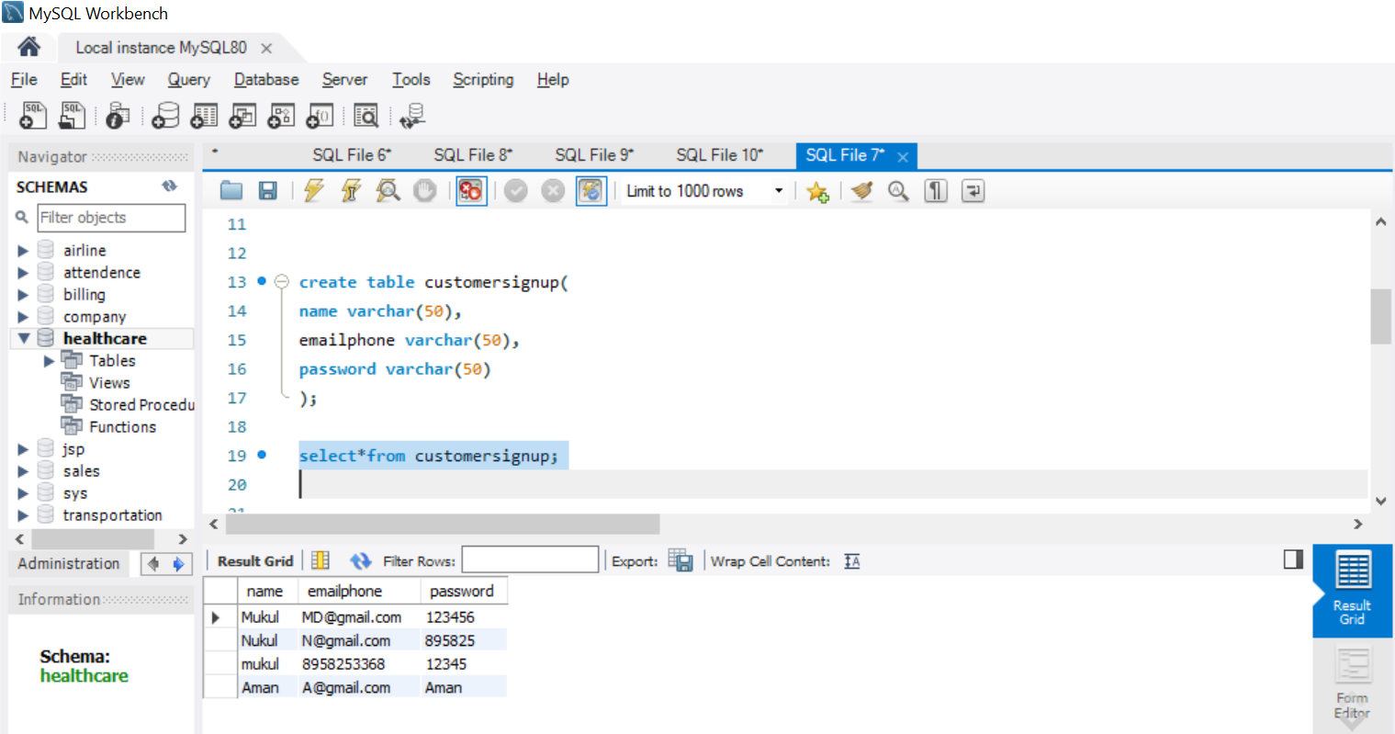

**Figure - 12**

**Book Appointment Database:-**

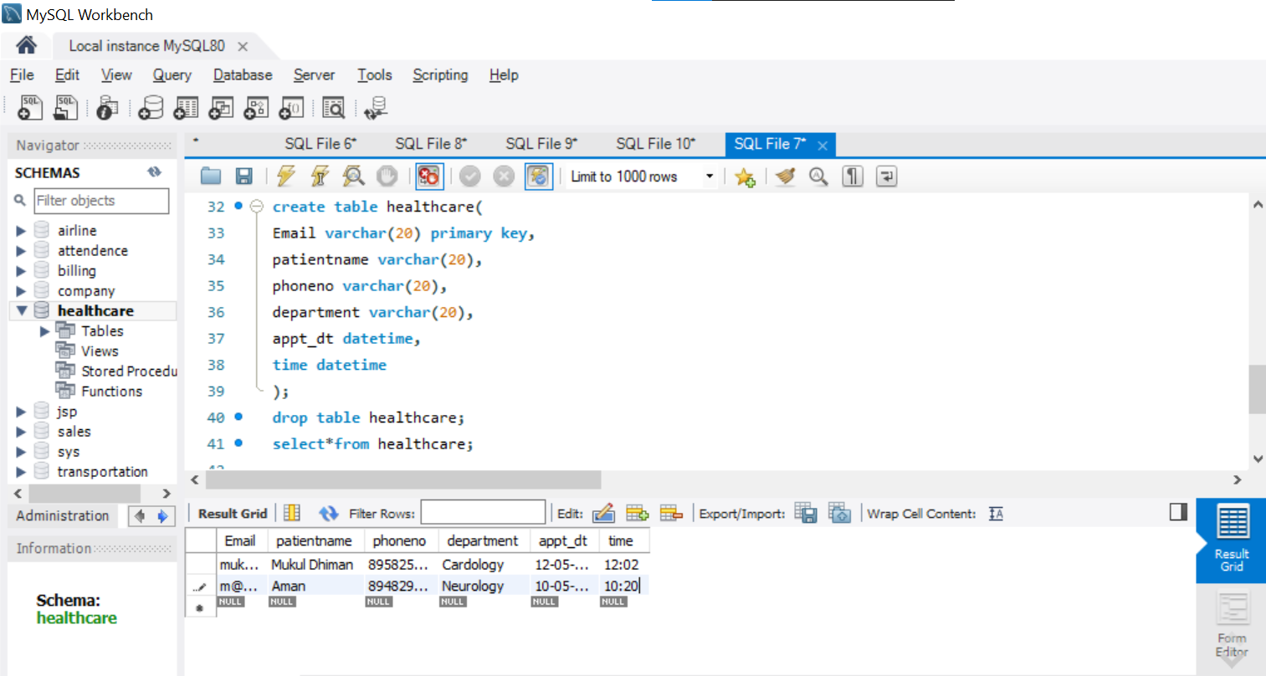

**Figure – 13**

### REFERENCES

1. Oracle. (n.d.). Java EE 7 Tutorial: Servlets. Retrieved from  
<https://docs.oracle.com/javaee/7/tutorial/servlets.htm>  
➤ Used for backend development using Java Servlets to process HTTP requests, manage sessions, and implement business logic.

2. W3Schools. (n.d.). HTML, CSS, and JavaScript Tutorials. Retrieved from  
[https://www.w3schools.com](https://www.w3schools.com/)  
➤ Used for designing and developing the user interface using HTML5, CSS3 for layout and styling, and JavaScript for client-side interactivity.

3. MySQL. (n.d.). MySQL 8.0 Reference Manual. Oracle Corporation. Retrieved from  
<https://dev.mysql.com/doc/refman/8.0/en/>  
➤ Used for designing and querying the project’s relational database, including tables for patients, doctors, appointments, and prescriptions.

4. GeeksforGeeks. (n.d.). Introduction to Java Servlets. Retrieved from

https://www.geeksforgeeks.org/servlets-in-java/  
➤ Used as a practical guide to implement Java Servlet logic, session handling, and database connectivity via JDBC.

5. TutorialsPoint. (n.d.). Servlets - Overview. Retrieved from  
https://www.tutorialspoint.com/servlets/  
➤ Provided examples and explanations for HTTP methods, servlet life cycle, and deployment in a web container.

6. Stack Overflow Community. (n.d.). Common Issues in Java Servlet and MySQL Integration. Retrieved from  
[https://stackoverflow.com](https://stackoverflow.com/)  
➤ Utilized for troubleshooting backend issues like JDBC connection handling, SQL exceptions, and data retrieval.

7. NetBeans IDE Documentation. (n.d.). Developing Web Applications with Java EE in NetBeans. Retrieved from  
<https://netbeans.apache.org/kb/docs/web/index.html>  
➤ Used for setting up the development environment, creating web modules, and deploying Java Servlet applications.